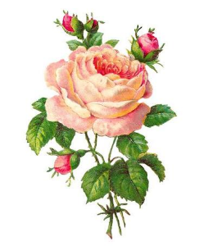


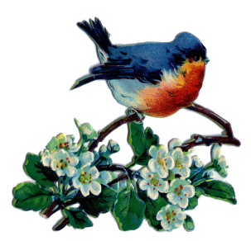


October/November/December 2026
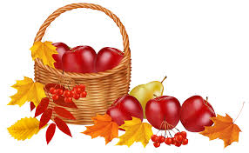

Our ministry vision for the Virginia Annual Conference is “to be disciples of Jesus Christ who are lifelong learners, who influence others to serve.”

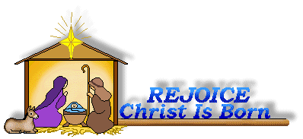
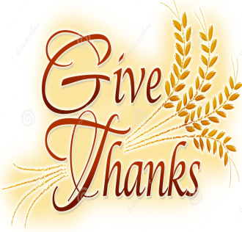
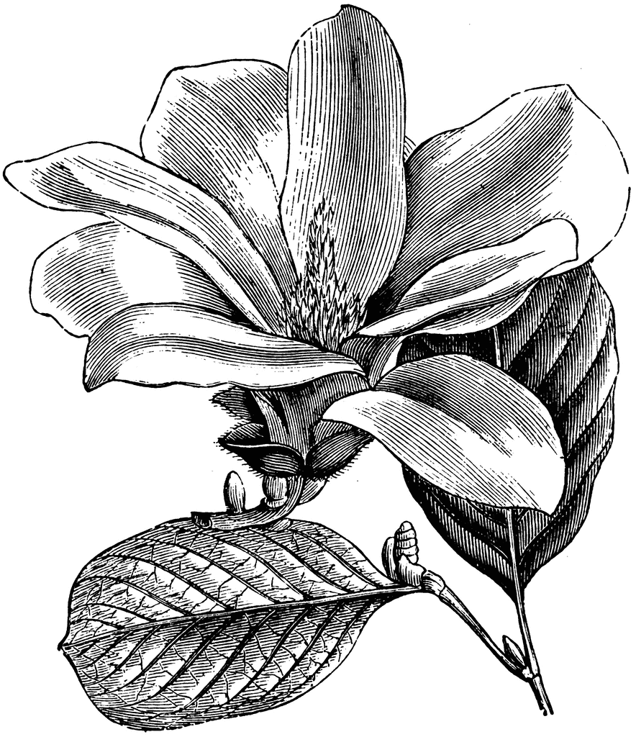
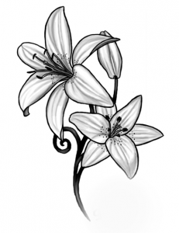

From Pastor Adam

Falling into Autumn
The earth has yielded its increase;
God, our God, has blessed us.

May God continue to bless us;
let all the ends of the earth revere him. (Psalm 67:6-7)

September 22nd marks the first day of Autumn – the season that is not quite summer, not quite winter, but somewhere in between. While often used interchangeably, the terms “autumn” and “fall” each have their own distinct histories.
Autumn appears in English during the 1300s as a derivative of the Latin word Autumus, and Autumus is derived from an even older Etruscan word meaning “to increase.” Thus, in its original form, the word “autumn” became closely linked with harvest and bringing forth the good gifts of food and produce God gives us through the mystery of creation (God’s increase, if you will). Before Autumn (or Fall) became a common term, speakers of Old English would simply call this period of time between summer and winter “harvest” – however, since there were other times when crops would be harvested (outside of the time between summer and winter) it became necessary to give this season its own name, and that is why “Autumn” came into fashion. During the 1500s, it became common for poets to refer to this season as “the fall of the leaf”, since in the northern hemisphere trees were losing their leaves at this time. Since all human language is prone to abbreviation, “the fall of the leaf” was soon shorted into “Fall” – a somewhat
newer word than “Autumn.” I love the notion of a season of increase, not merely in the sense of the good gifts of the earth that feed us, but a sense of spiritual increase as well. I pray that this in-between time marks a period of spiritual increase for us. Perhaps the cool mornings will give us more cause to stay indoors and read a bit more of the Good Book. Perhaps a slower start to our days might add more time for prayer and meditation.
As the increase pours forth from the fields, so may God increase spiritual fruit in us, as faith, hope, and love spring forth from our lives into the greater world. May our compassion, devotion, and service increase in us during this rich season of increase. Whatever gifts of the Spirit we have, may God increase them as we fall into this Autumn.

~God bless you my friends, Adam


Congratulations to Andrew & Katie Jessen Bodamer on the birth of their daughter, Lilyana Rae Bodamer, born on October 6, 2026. The proud grandmother is Jennifer Jessen and the proud great-grandmother is Linda Jessen. Best wishes to all!

Circle News

The Merry Marthas Circle will meet on Thursday, October 15, at 10:30, at church. We will have our annual pledge service, filling out pledge cards for 2027. We will also send cards (that Sharon Mayhew has made) to shut-ins or those with health issues. We will also meet on Thursday, November 19, at 10:30, for the World Thank Offering. These meetings will be followed by lunch at Charley's. We will not meet in December, January, or February
~Judy Robertson

The Wesleyan Group will meet on Monday, October 12th, 7:00 p.m., at the home of Linda Jessen. On Monday, November 9th, 7:00 p.m., at the home of Betty Taylor. And on Monday, December 14th, 6:30 p.m., at Charley’s. ~Ann Robbins


The choir will be singing on Sundays, October 4 & 25, November 8 & 29, December 13 & 27. We will be rehearsing at 10:00 a.m. We will sing familiar hymns so come join us! ~Sharon Mayhew, Director of Music


Food Cart: October/November/December
Side dishes for the holidays ~ canned vegetables, cranberry sauce, stuffing mix, canned yams, etc. No “baked goods”! Place donations in the grocery cart, located in the Commons.

Friends Who Care

All participants please fill out the Care Sheet placed in the Commons or email your reports of visits and phone calls to mx55566@gmail.com. On your report please note the month and year, names of those visited (or called) and the number of times visited or called. We express our appreciation to all the volunteers who participate in this ministry of compassion. If you would like to volunteer contact Scottie Nuckols. A total of 1 phone call, 6 cards were sent for July, August, and September. Thank you!


Missions Report
Our Park View food cart donation for this past quarter was 94 lbs. This was a good boost for their pantry. We will be collecting food to make side dishes for the holidays. Canned vegetables, cranberry sauce, stuffing mix, canned yams, anything you think of that would make a festive meal. Thank you for your generous support of this mission. ~Thank you, Linda Jessen & Mission Committee


We celebrated The 100th birthday of J. Owen Stinnette on Saturday,
October 10, 2026 here at Chestnut Hill UMC. Congratulations!!


~Those Who Serve ~
WORSHIP LEADERS
OCTOBER GREETERS
October 4 ~Jane White
October 11 ~Judy Robertson
October 18 ~Mary Walker
October 25 ~Dan Robertson
NOVEMBER GREETERS
November 1 ~Ann Robbins
November 8 ~Maggie Musgrove
November 15 ~Betty Taylor
November 22 ~Judy Robertson
November 29 ~Jane White
DECEMBER GREETERS
December 6 ~Mary Walker
December 13 ~Dan Robertson
December 20 ~Ann Robbins
December 27 ~Betty Taylor
WORSHIP LEADERS
October 4 ~Ann Robbins
November ~Linda Jessen
December 20 ~Judy Robertson

1 Pat Short
2 Nancy Lee
Emily V.
Fernandez
3 Michael McGlothlin
6 Kirsten Bell
Tim Crist
Dennis Tolley
7 Kenny Busic
Cheryl Powell
9 Owen Stinnette
Jeremey
VandeBogart
11 Landen Glass
12 Camden Mason
14 Wade Ware
16 Burton Brooks
Terry Palazzi
Anne-Elaine Tiller
17 Suzanne
Marshall
Blake Phillips
18 Sharon
Rickmon
19 Connie Yost
20 Erin Ecklund
21 Steven Kinzer
22 C.O. Bell
25 Frankie
Hardwick
28 Jacqueline Busic
Cheryl Thomas
29 Wes Robbins
Ricky Smith
31 Robert Baunach

2022
March 2022

Our Church Financial Picture
Through the end of September 2026
General Operating Funds:
Needed to meet our 2026 Budget $ 181,480.00
Needed to meet our budget to date $ 136,109.99
Actual receipts to date $ 132,103.90
Shortage to meet budget to date $ 4,006.03
Actual expenditures to date $ 141,413.25
Shortage to meet expenses to date $ 9,309.35
Special Offerings* (not budgeted):
Received to date $ 7,530.00
Dispersed to date $ 6,820.00
*Christmas, Easter, Annual Conference,
World Communion, etc.
Thank you for your generosity.

Birthdays… 
October Birthdays
2 Emily V.
Fernandez
7 Kenny Busic
9 Owen Stinnette
Jeremey
VandeBogart
Cathy Wyatt
11 Landen Glass
12 Camden Mason
16 Burton Brooks
Terry Palazzi
Anne-Elaine Tiller
20 Erin Ecklund
21 Steven Kinzer
28 Jacqueline Busic
29 Wes Robbins

December
Birthdays
1 Ron Hood
6 Jennifer Jessen
10 Ann Compton
13 Heather Stewart
16 Glenn Collins
17 Chris Glass
Susan Putnam
18 Linda Stables
21 Rev. Becky Cloud
Rebecca Steward
22 Jane White
23 Linda Jessen
29 Cookie Fish
November Birthdays
1 Jessica Robbins
5 Christopher Palazzi
8 Karsen Burgess
9 Sylvia Glass
10 Elizabeth Ashworth
11 Casey Fish
13 Pat Moore
14 Kathleen Baker
Jane Hood
16 John Martin, Jr.
Maggie Musgrove
17 Frank Stewart
24 Ann Ruhland
25 D’Lynn Burgess
Elizabeth Candler
26 Ella Dunn
27 Tad LeFew, III
30 Phillip Yost


*Angel Tree
*Mitten Tree Trunk
*Decorating Church For Christmas
*Christmas Eve Candlelighting Service
*Christmas Offering
*Estimate of Giving 2027
(Cards will be available at church
or request by mail.)
***Information on all events will be provided in upcoming bulletins!


Daylight Saving Time ends on Sunday, November 2nd. Remember to FALL back one (1) hour on Saturday evening, November 1st.

Coming Up…
Annual Charge Conference, Mountain View District ~ Sunday, November 15, 2026
3:00 p.m.~ Chestnut Hill UMC

Honorarium

In Honor Of:
J. Owen Stinnette
(For 100th Birthday)
Given by: Frances Unruh


Chestnut Hill United Methodist Church extends Christian love and sympathy to the family of Patricia “Pat” Short and especially to her children, Susan, Stephen, & Diana. Mrs. Short passed away on October 5, 2026.
And to the family of Bertha Arthur and especially to her sister-in-law, Scottie Nuckols. Mrs.
Arthur passed away on September 27, 2026.

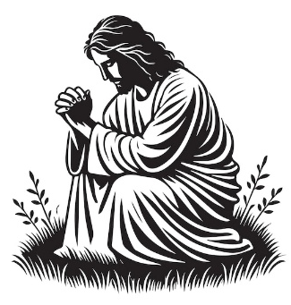
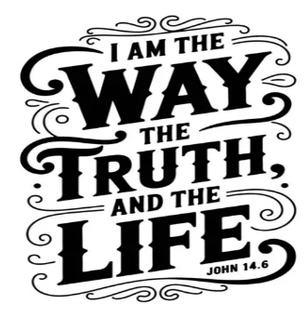


In Memoriam
Gloria Brooks Coleman
January 5, 1945 - June 7, 2026
Marsha Allen Burks
March 26, 1952 - July 13, 2026
Thomas “Tom” Evans
September 19, 1941 – July 12, 2026
Robbie Duff Perrow
May 23, 1932 – July 20, 2026
Dorothy Elaine Burleson Clarke
February 25, 1937 – July 23, 2026
Patricia “Pat” Short
October 1, 1934 - October 5, 2026

Gifts & Memorials
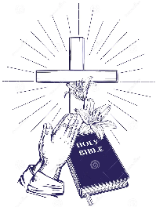
In Memory
Marsha Burks
Given by: Fred & Sue Norvelle, Dan & Judy Robertson,
Chet & Mary Walker
Gene & Neta Pearson
Given by: Chet & Mary Walker
Robbie Perrow
Given by: David & Eleanor Maxham, Dan & Judy Robertson, Esther Stinnett,
Montvale Capital Management, Inc., Marvin & Sharon Tinsley, Martha Bryant,
David & Sally Almond, Beverly Farris, Frances Unruh, Bob Elium, Fred & Sue Norvelle,
Patsy Whitten, Don & Betty Havell, Wanda Mason, Betty Wilkins,
Judy Perrow & Family, Brenda Gowin, Kitty & Wilton Burgess
Elaine Clarke
Given by: Dan & Judy Robertson, Frances Unruh, Bob Elium, Fred & Sue Norvelle,
Herman & Rebecca Steward, David & Eleanor Maxham, Linda Jessen,
Susan Ferrentino, Laurie Mason, Kitty & Wilton Burgess
Gloria Coleman
Given by: Kitty & Wilton Burgess

GOOD NEWS will be published quarterly. Pick up your copy in the Commons or watch for it on our website: www.chestnuthillumc.net.

 Calendar of Events
Sundays—Sunday School, 9:30 a.m. ~ Worship Service, 10:30 a.m.
Fridays –Homeschool, 9:30 a.m. (School Year)
October
Sunday, October 4 Choir, 10:00 a.m.
Saturday, October 10 Owen Stinnette 100th Birthday Party, 1:00-4:00 p.m.
Monday, October 12 Columbus Day-Office Closed
Wesleyan Group @ Jessen Home, 7:00 p.m.
Tuesday, October 13 Homeschool Game Night, 7:00 p.m.
Thursday, October 15 Merry Martha’s Circle, 10:30 a.m.
Friday, October 23 Homeschool Set-Up for Costume Parties, 2:00 p.m.
Sunday, October 25 Choir, 10:00 a.m.
Friday, October 30 Homeschool Costume Parties, 9:30 a.m.
November
Thursday, November 5 Homeschool Set-Up Pictures, 2:00 p.m.
Sunday, November 8 Choir, 10:00 a.m.
Monday, November 9 Wesleyan Group @ Taylor Home, 7:00 p.m.
Tuesday, November 10 Homeschool Game Night, 7:00 p.m.
Sunday, November 15 Charge Conference (Chestnut Hill UMC), 3:00 p.m.
Thursday, November 19 Merry Martha’s Circle, 10:30 a.m.
Saturday, November 21 Homeschool Fair, 9:00 a.m.
Thursday, November 26 & Friday, November 27 ~ Thanksgiving Holiday, Office Closed
Sunday, November 29 Choir, 10:00 a.m.
December
Thursday, December 3 Homeschool Set-Up, 2:00 p.m.
Friday, December 4 Homeschool/Holiday Parties, 9:30 a.m.
Tuesday, December 8 Homeschool Game Night, 7:00 p.m.
Sunday, December 13 Choir, 10:00 a.m.
Monday, December 14 Wesleyan Group @ Charley’s, 6:30 p.m.
Thursday, December 24 Office Closed
Christmas Eve Worship Service TBA
Friday, December 25 Merry Christmas~Office Closed
Sunday, December 27 Choir, 10:00 a.m.

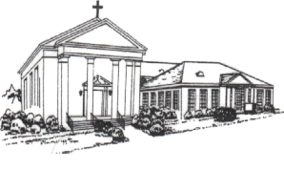
Chestnut Hill United
Methodist Church
4660 Fort Avenue, Lynchburg, VA 24502
Phone Number: 434-239-8423
E-mail: chestnuthillumc@comcast.net
On the web: www.chestnuthillumc.net

Church Office Hours
Monday-Thursday~9:00 am—3:30 pm
Friday~9:00 am-1:00 pm

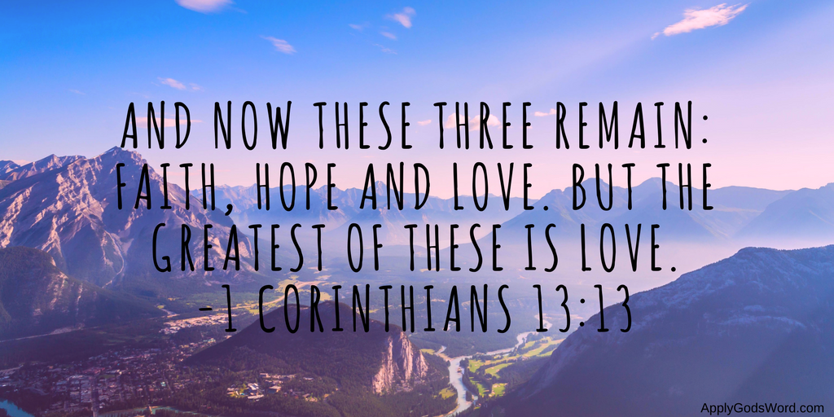

DIRECTORY OF
CHESTNUT HILL UNITED METHODIST CHURCH
 | Sue Haupert-Johnson | Richmond Area Resident Bishop
 | Rev. Dr. Sarah Calvert | Mountain View District Superintendent
 | Adam White | Minister
 | Monica Campbell | Administrative Assistant
 | Sharon Mayhew | Director of Music Ministry
 | Judy Martin | Bookkeeper
 | Judy Robertson | Lay Leader
 | Elizabeth Nichols | Missionary in Henry County

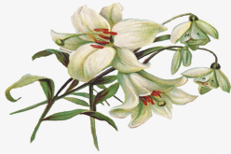

January 2022
2022
April 2022
April 2022
March 2022

